This is to certify that

_________________________

has attended the 90 minute webinar - Trigger Points with Jan Dommerholt &
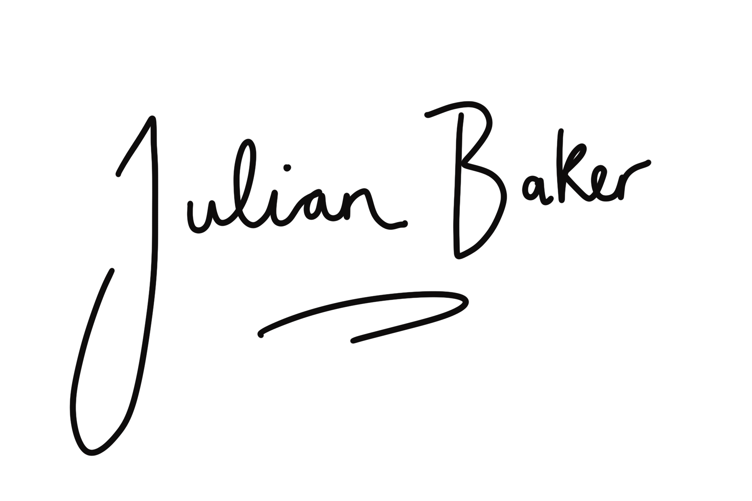
Julian Baker
julian@functionalfascia.com

