This is to certify that

_________________________

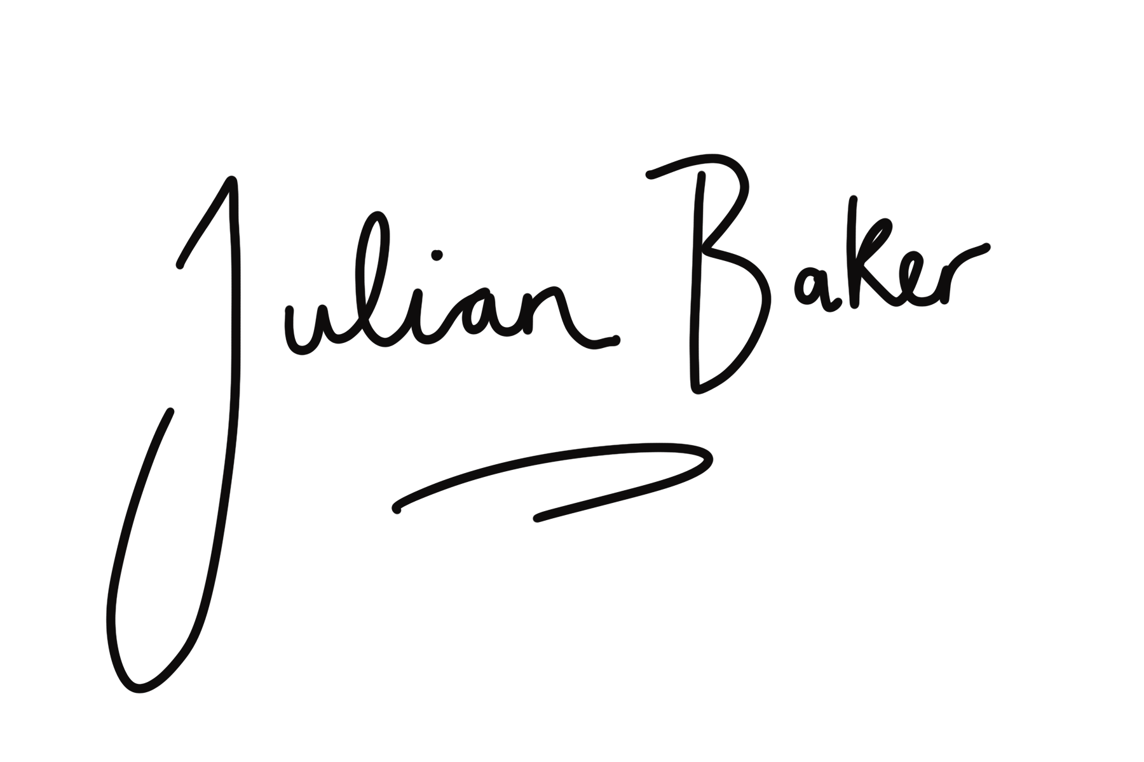
has attended the 90 minute webinar - All things Muscle with Julian Baker & Chris Neil
julian@functionalfascia.com

