This is to certify that

_________________________

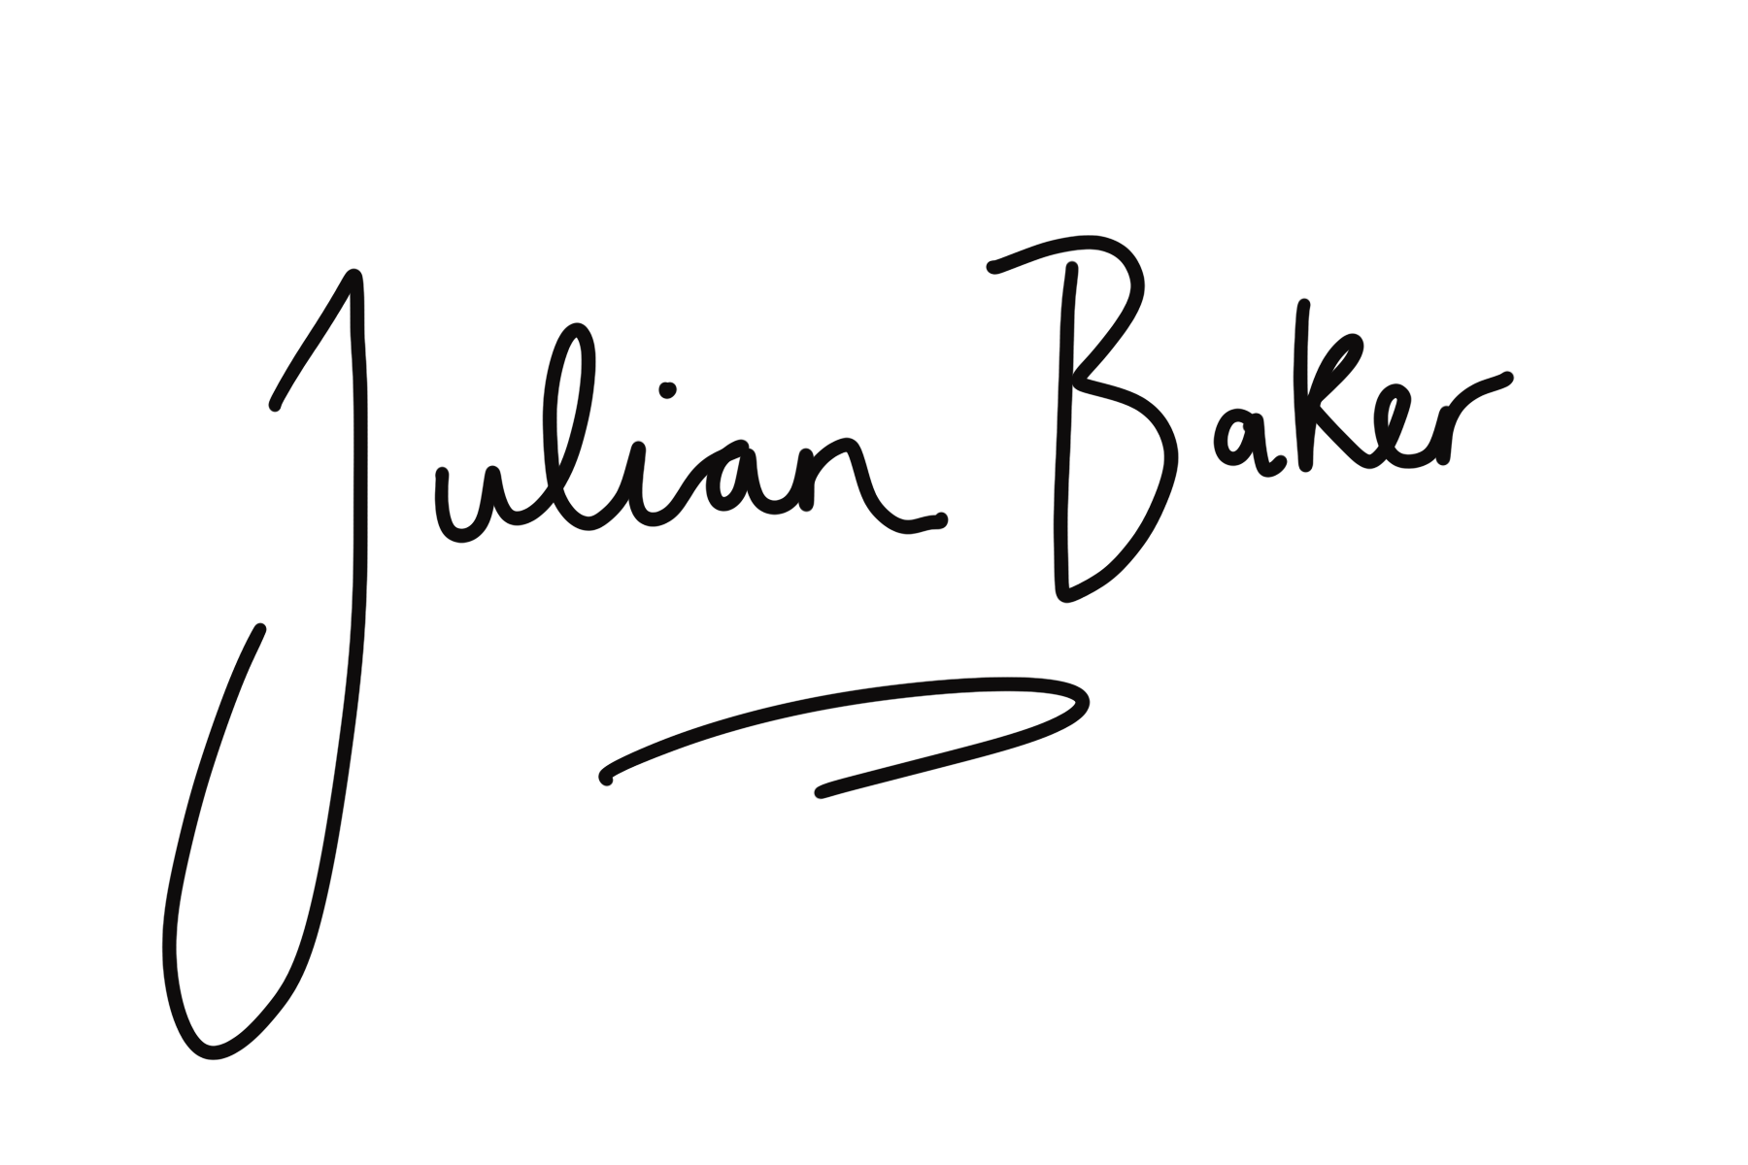
has attended the 90 minute webinar - Superficial Fascia & Adipose
Covering anatomy, fascia & functional movement with Julian Baker
julian@functionalfascia.com

