This is to certify that

_________________________

has attended the 90 minute webinar - Pelvic Floor.
Covering anatomy,
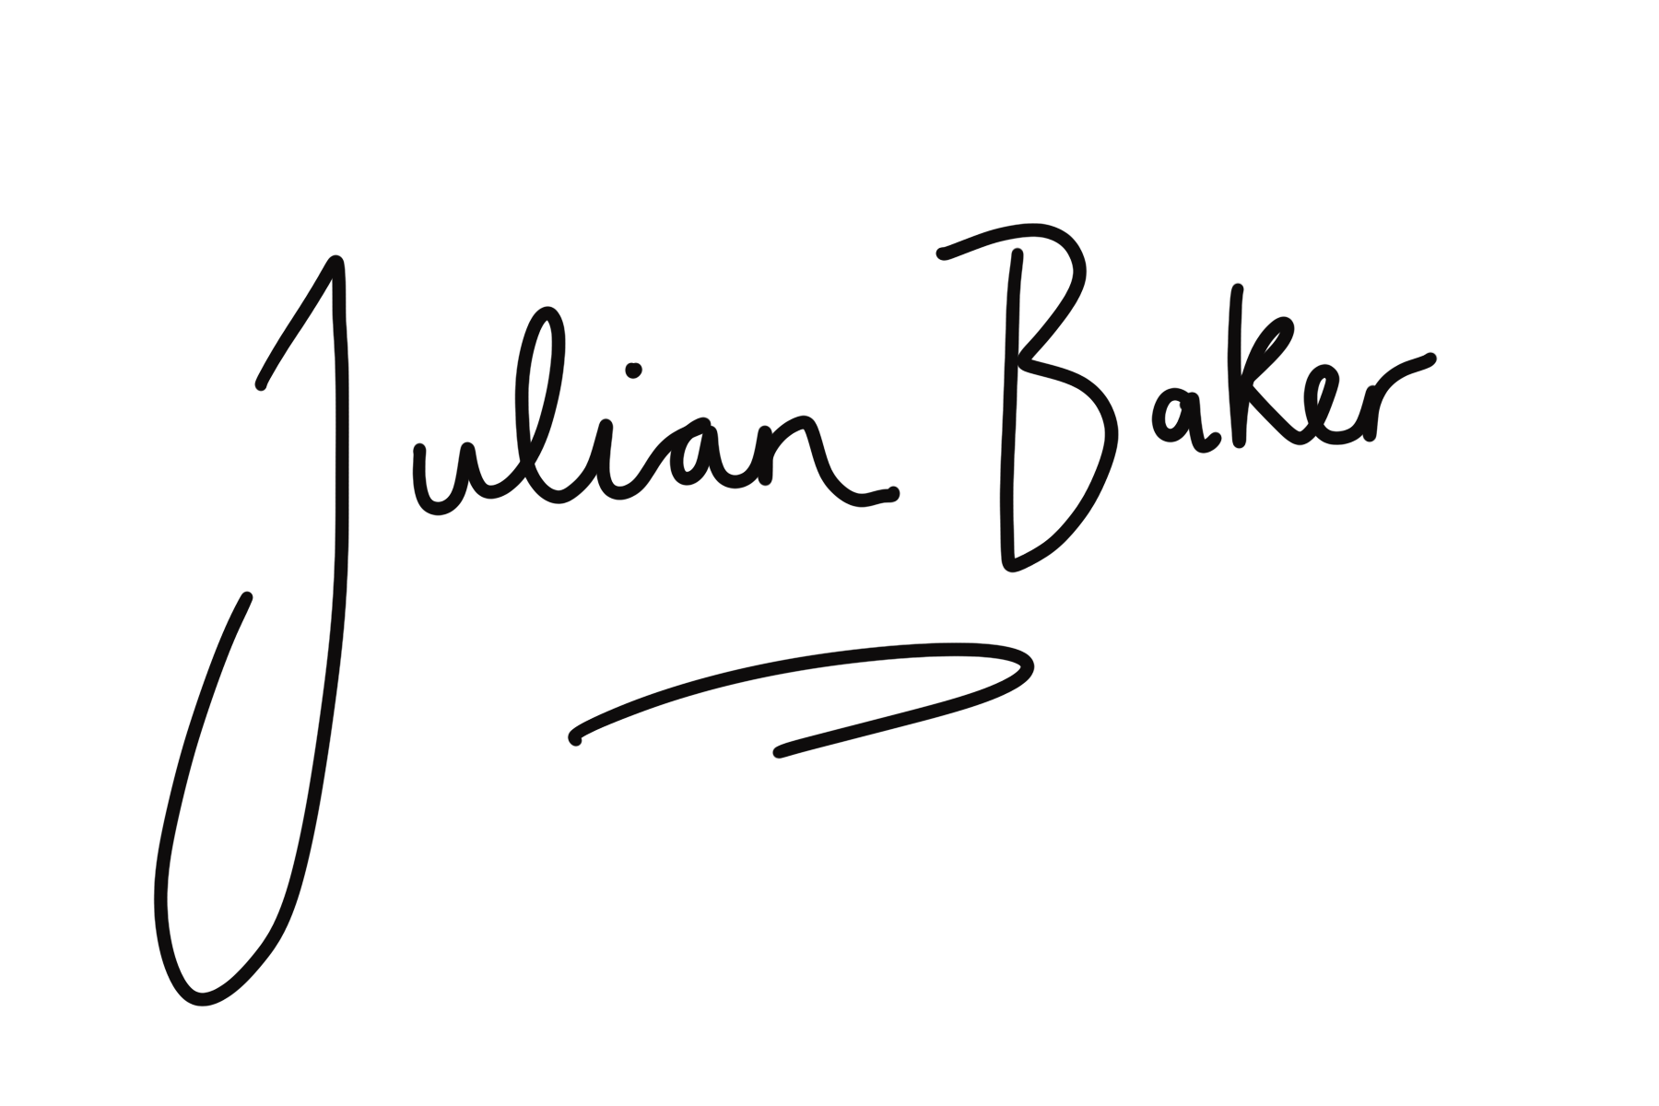
fascia & functional movement with Julian Baker & Dr Jenny Wickford
julian@functionalfascia.com

