This is to certify that

_________________________

has attended the 90 minute webinar - Neuro Anatomy.
Covering anatomy,
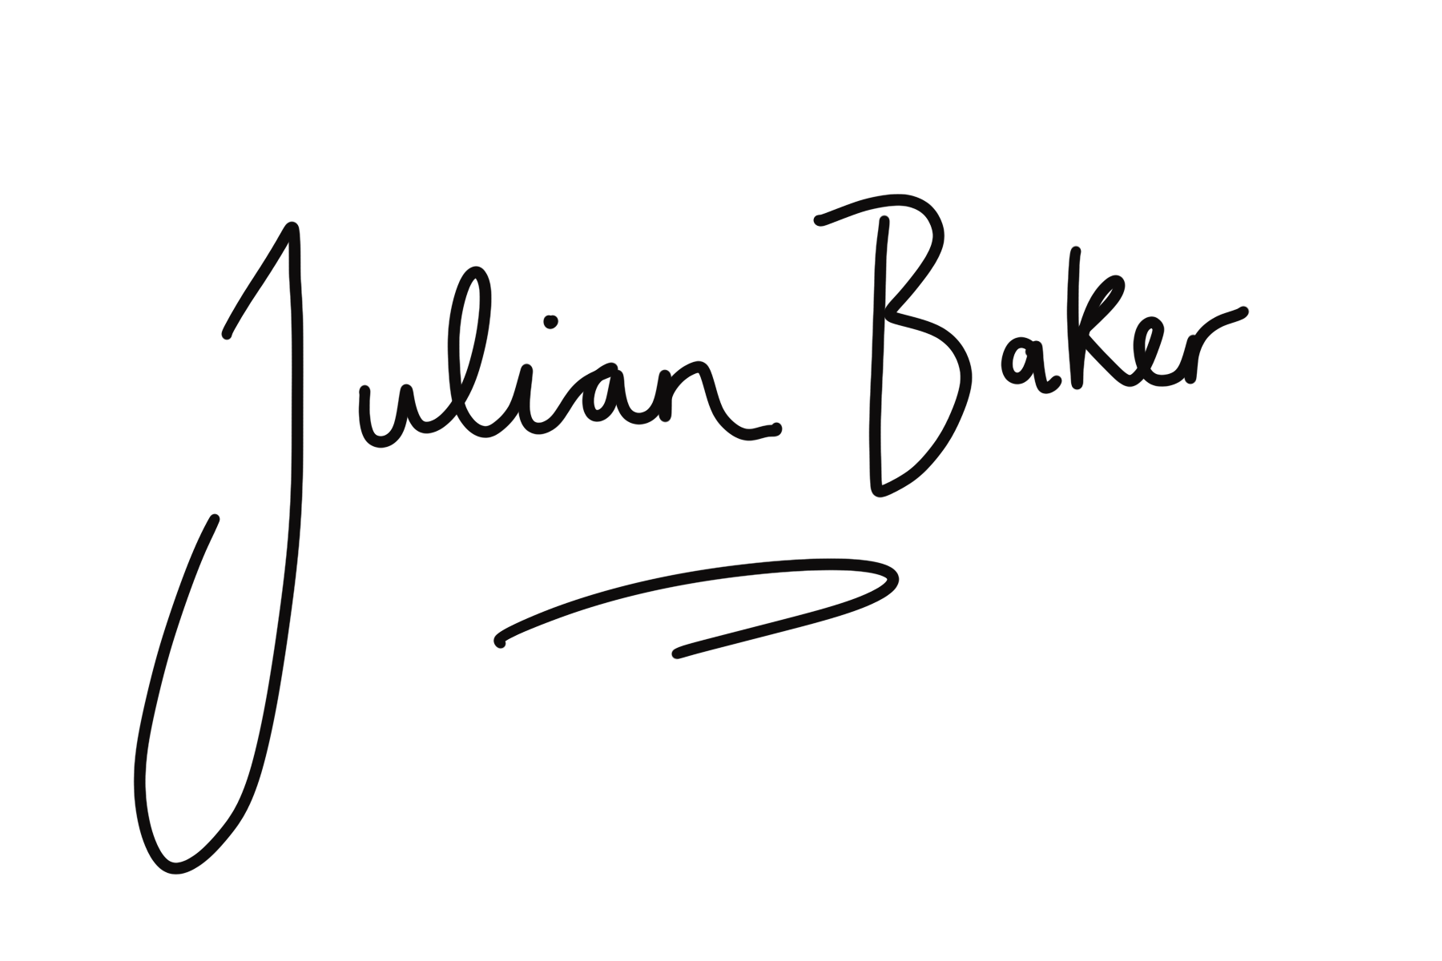
fascia & functional movement with Julian Baker & Dr Nick Marcer
julian@functionalfascia.com

