This is to certify that

_________________________

has attended the 90 minute webinar - Functional Breathing.
Covering anatomy,
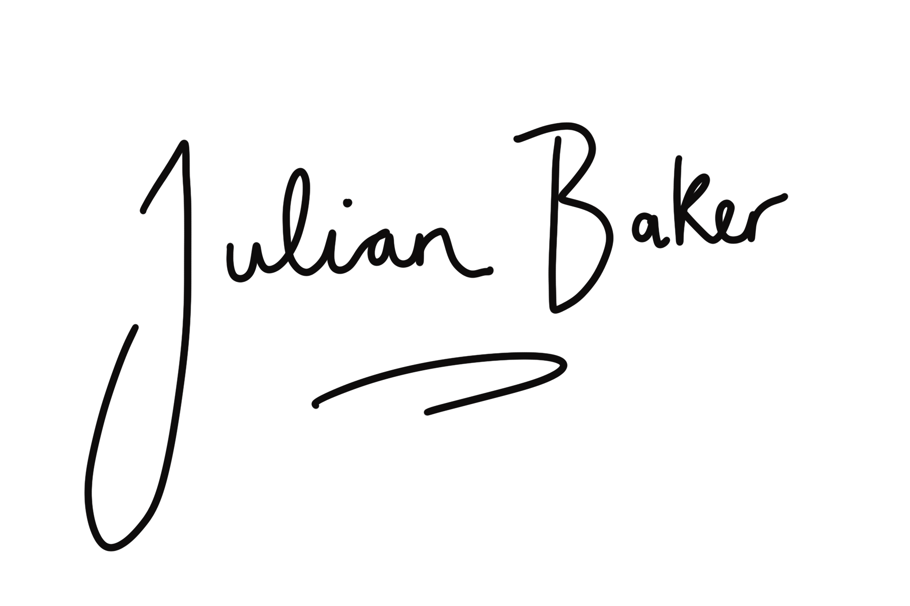
fascia & functional movement with Julian Baker and Ana Barretxeguren
julian@functionalfascia.com

