This is to certify that

_________________________

has attended the 90 minute webinar - Pelvis and SI Joint
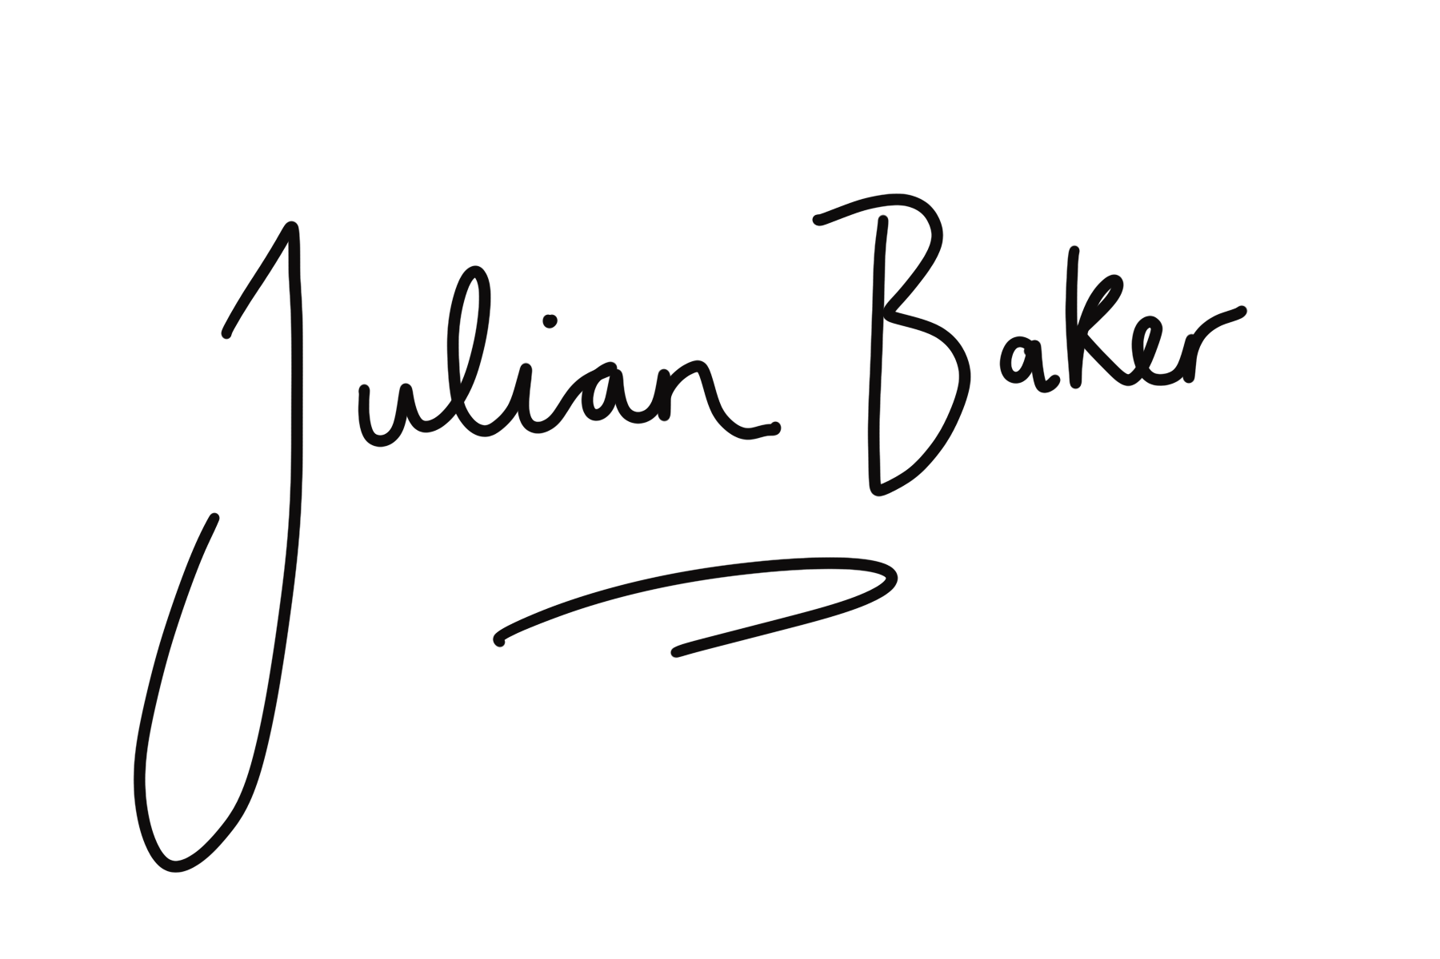
Covering anatomy, fascia & functional movement with Julian Baker
julian@functionalfascia.com

