This is to certify that

_________________________

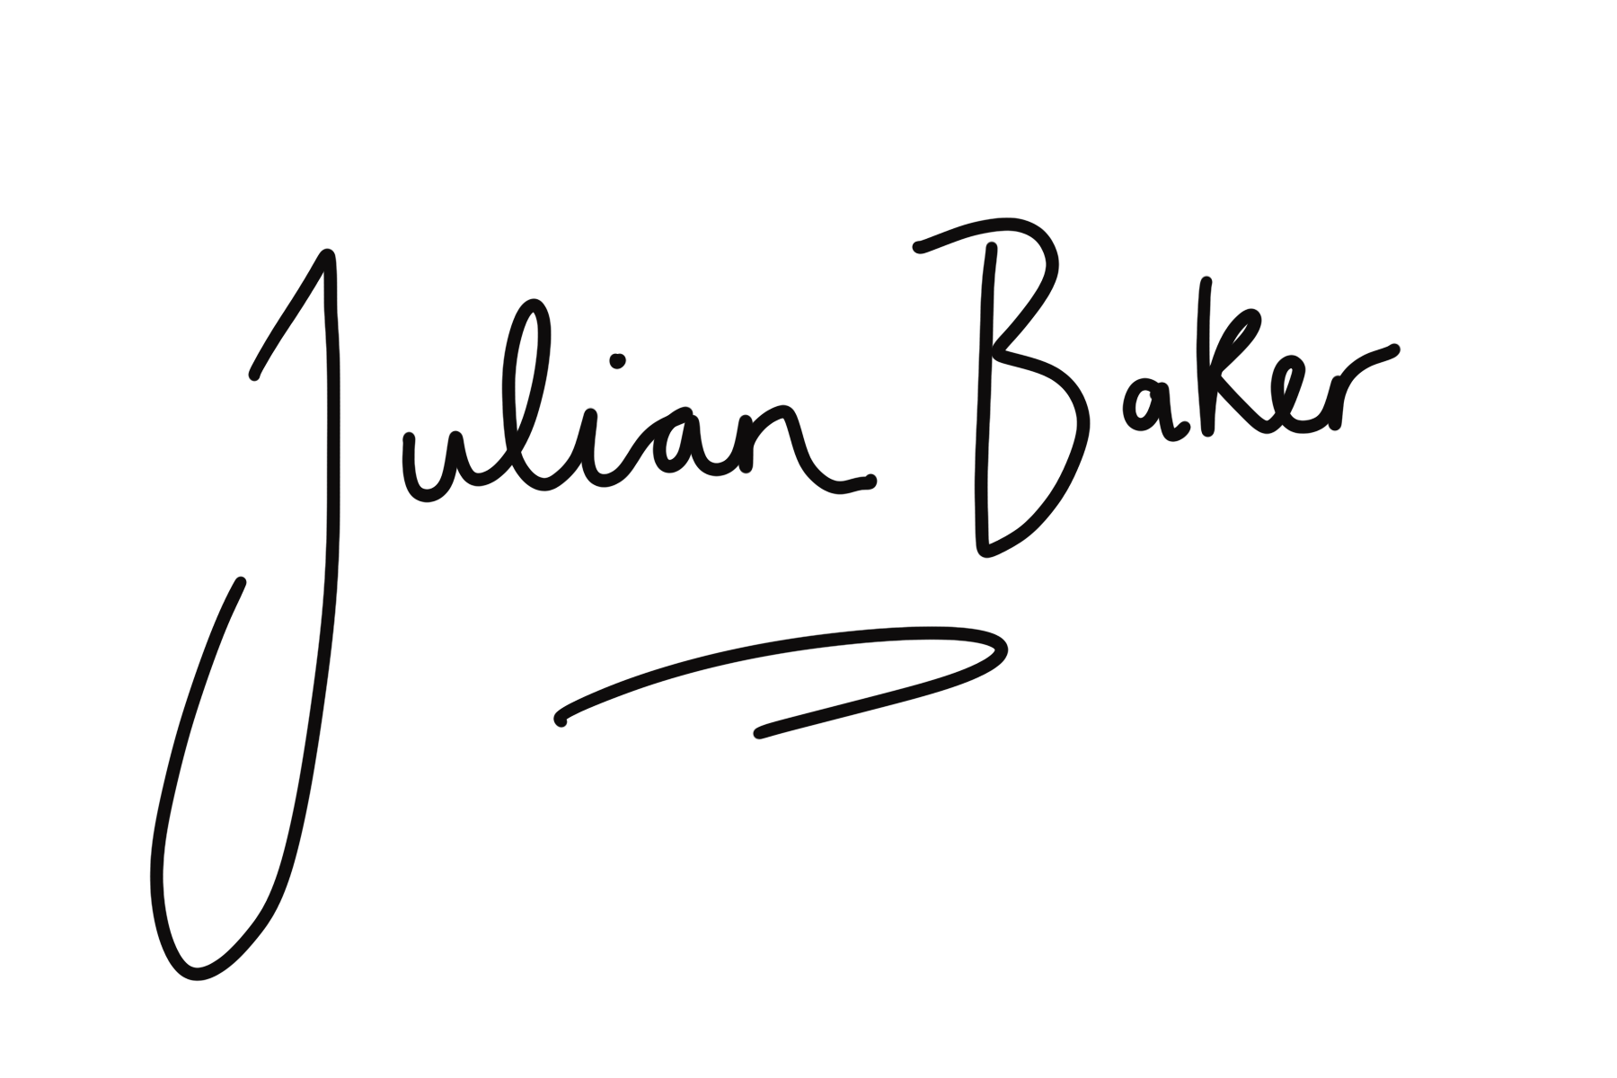
has attended the 90 minute webinar exploring The Psoas
Covering anatomy, fascia & functional movement with Julian Baker
julian@functionalfascia.com

