This is to certify that

_________________________

has attended the 90 minute webinar
exploring the anatomy of the respiratory system
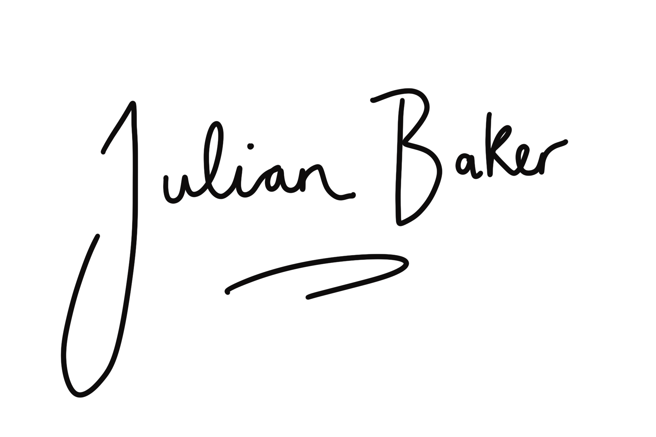
with Julian Baker
julian@functionalfascia.com

