This is to certify that

_________________________

has attended the 90 minute webinar - Deep Fascia - Part One.
Covering anatomy,
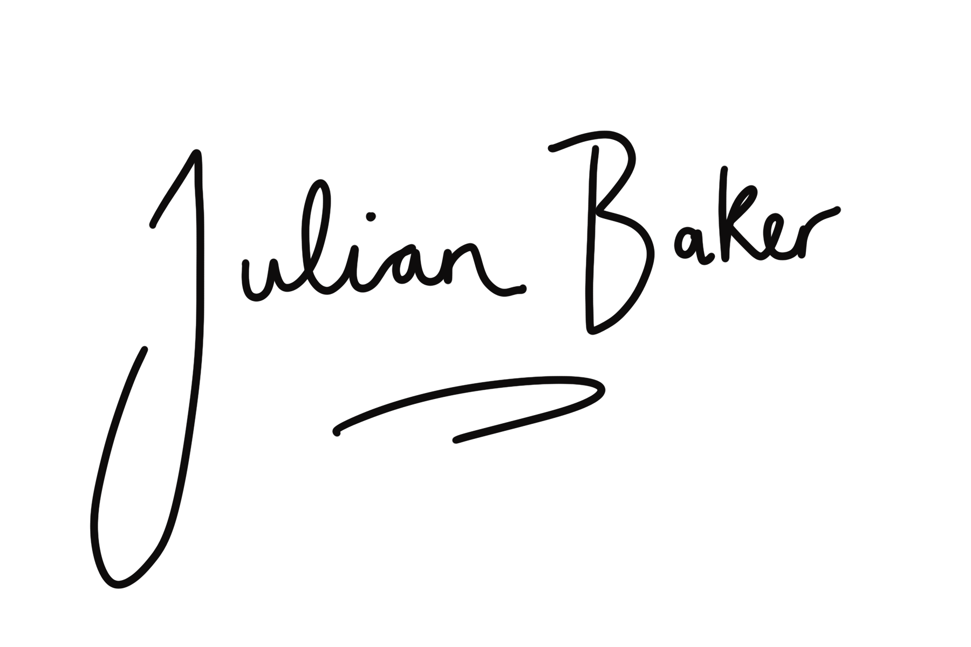
fascia & functional movement with Julian Baker
julian@functionalfascia.com

