This is to certify that

_________________________

has attended ____ hours
of webinars covering anatomy,
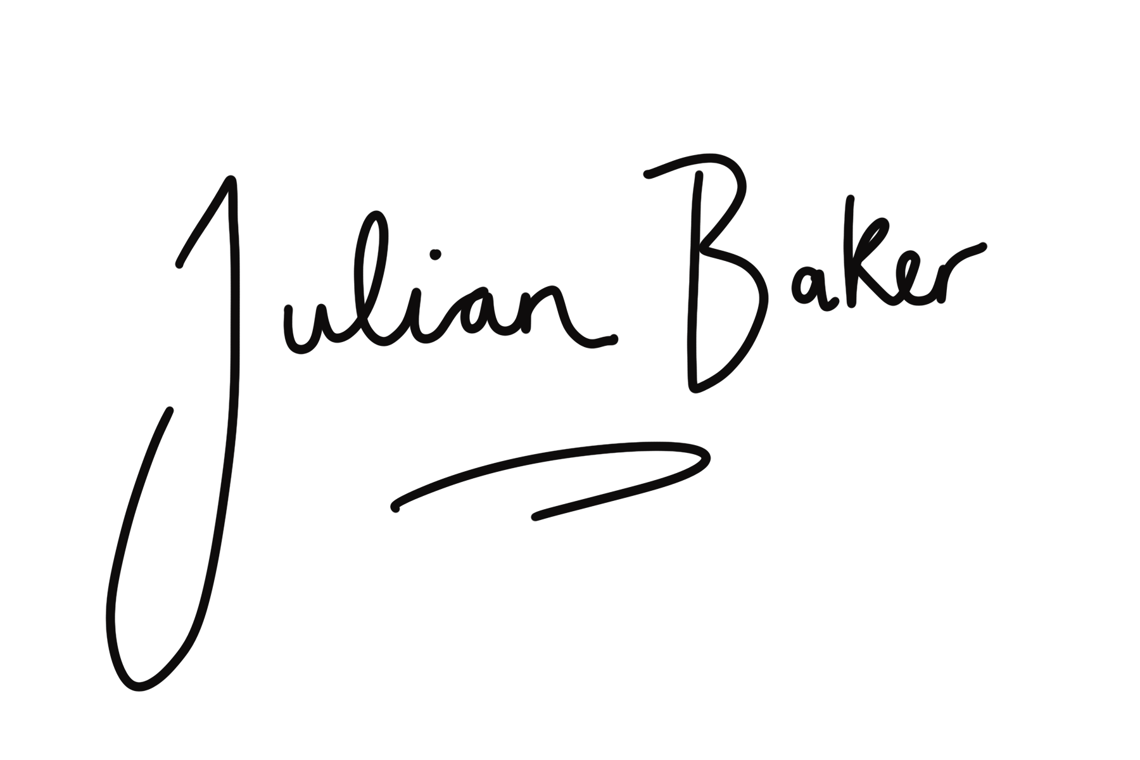
fascia & functional movement
julian@functionalfascia.com

